Create Table Exercise

Given the following ERD, create all 5 tables with the appropriate primary and foreign keys. Include Check constraints and Defaults on the appropriate columns.
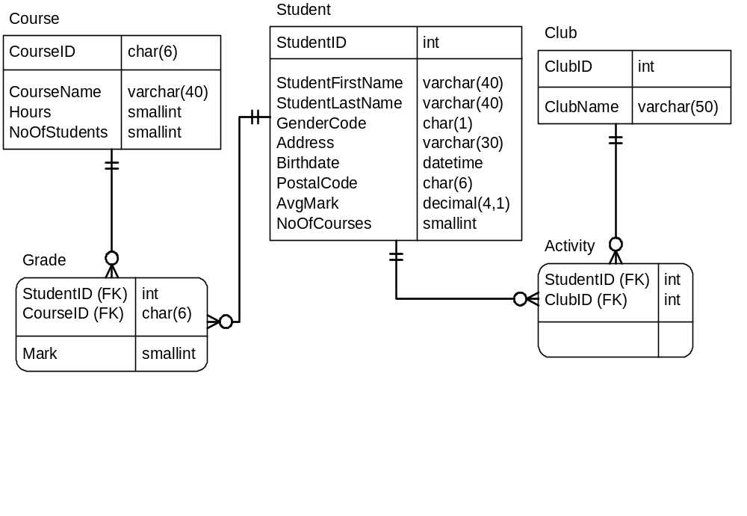

COLUMN NAME | DOMAIN LIMIT(S) | REQUIRED
StudentID |  | YES
StudentFirstName |  | YES
StudentLastName |  | YES
GenderCode | “F” or “M” | YES
Address |  | NO
Birthdate |  | NO
PostalCode | A9A9A9 | NO
AvgMark | Between 0 and 100 | NO
NoOfCourses | >=0, Default = 0 | NO
CourseID |  | YES
CourseName |  | YES
Hours | > 0 | NO
NoOfStudents | >=0 | NO
ClubID |  | YES
ClubName |  | YES
StudentID |  | YES
CourseID |  | YES
Mark | Between 0 and 100, Default = 0 | NO
StudentID |  | YES
ClubID |  | YES

